**JSS MAHAVIDYAPEETHA**

**JSS SCIENCE AND TECHNOLOGY UNIVERSITY**

JSS Technical Institution Campus Mysore -- 570006



A Project Report on

**“WEB PROGRAMMING”**

Submitted by:

**SUMANTH S**

**USN:01JST16IS045**

Submitted to:

**Prof. C.K ROOPA**

Assistant Professor

DEPARTMENT OF INFORMATION SCIENCE AND ENGINEERING

2018-2019

**CITIZEN COMPLAINT HANDLING DATABASE**

**Problem statement:**

A good society is made when the citizens are safe and sound. But, when any mishap, it is the responsibility of the police task force to handle it. Without such a database, it would be difficult to handle the crimes being done to the citizens. A record needs to be maintained about the citizens of a society to serve them better and better understanding of the problems of the citizens.

For example, if a person had me an unfortunate car accident, we have to make a record of that mishap. Speaking precisely, we need to hold all the data during and after the mishap such as the citizen’s hospital expenses and if that specific person is covered by insurance.

**Goal of the project:**

The goal of the project is to record all the complaints given by the citizens in a database and to let the police task force to act accordingly if they are to be involved. If un-fortunately a person had to go to a hospital then it too is recorded and the insurance amount is given accordingly. Overall, it helps in organising the accidents of a city and thereby reducing the clutter for the police task force.

In order to record the data and display data from the database as when as required, we use Database Management concepts to efficiently store data and retrieve it. Here, we used MariaDB as the language used to access the database to insert, retrieve or to manipulate data. This database’s main objective is to effective handling of the complaints and accidents faced by the citizens.

**About website:**

The Goal of the conceived WEB project is to provide a generalized report (to the public) of a complaint or accident database happening in the city with a clean and easy user interface and navigation.

We make use of several technologies to build a robust website for our complaint handling database. The server is accessed through connecting the UI to the server though PHP. For the user interface, we have used HTML5 and CSS3. For an interactive web session, we have used javascript too.

**Technologies used:**

1). HTML5 and CSS3

2). Javacript

3). MariaDB

**HTML:**



**HyperText Markup Language** (**HTML**) is a markup languagefor creating a webpage. Webpages are usually viewed in a web browser. They can include writing, links, pictures, and even sound and video. HTML is used to mark and describe each of these kinds of content so the web browser can display them correctly. HTML can also be used to add meta information to a webpage. Meta information is usually not shown by web browsers and is data *about* the web page, e.g., the name of the person who created the page. CSS is used to style HTML elements while Javascript is used to manipulate HTML elements and CSS styles.



**Cascading Style Sheets** (**CSS**) is a style sheet language used for describing the presentation of a document written in a markup language like HTML. CSS is a cornerstone technology of the World Wide Web, alongside HTML and JavaScript.

CSS is designed to enable the separation of presentation and content, including layout, colors, and fonts. This separation can improve content accessibility, provide more flexibility and control in the specification of presentation characteristics, enable multiple web pages to share formatting by specifying the relevant CSS in a separate .css file, and reduce complexity and repetition in the structural content.

Separation of formatting and content also makes it feasible to present the same markup page in different styles for different rendering methods, such as on-screen, in print, by voice (via speech-based browser or screen reader), and on Braille-based tactile devices. CSS also has rules for alternate formatting if the content is accessed on a mobile device.

The name *cascading* comes from the specified priority scheme to determine which style rule applies if more than one rule matches a particular element. This cascading priority scheme is predictable.

**Javascript:**



Alongside HTML and CSS, JavaScript is one of the three core technologies of the World Wide Web. JavaScript enables interactive web pages and thus is an essential part of web applications. The vast majority of websites use it, and all major web browsers have a dedicated JavaScript engine to execute it.

As a multi-paradigm language, JavaScript supports event-driven, functional, and imperative (including object-oriented and prototype-based) programming styles. It has an API for working with text, arrays, dates, regular expressions, and basic manipulation of the DOM, but the language itself does not include any I/O, such as networking, storage, or graphics facilities, relying for these upon the host environment in which it is embedded.

MARIA DB:



**MariaDB** is a community-developed fork of the MySQL relational database management system intended to remain free under the GNU GPL. Development is led by some of the original developers of MySQL, who forked it due to concerns over its acquisition by Oracle Corporation.

MariaDB intends to maintain high compatibility with MySQL, ensuring a drop-in replacement capability with library binary parity and exact matching with MySQL APIs and commands. It includes the XtraDB storage engine for replacing InnoDB, as well as a new storage engine, Aria, that intends to be both a transactional and non-transactional engine perhaps even included in future versions of MySQL.

**XAMPP:**



**XAMPP** is a free and open-source cross-platform web server solution stack package developed by Apache Friends, consisting mainly of the Apache HTTP Server, MariaDB database, and interpreters for scripts written in the PHP and Perl programming languages Since most actual web server deployments use the same components as XAMPP, it makes transitioning from a local test server to a live server possible.

XAMPP is regularly updated to the latest releases of Apache, MariaDB, PHP and Perl. It also comes with a number of other modulesincluding OpenSSL, phpMyAdmin, MediaWiki, Joomla, WordPress and more. Self-contained, multiple instances of XAMPP can exist on a single computer, and any given instance can be copied from one computer to another.

**CLIENT SIDE WEBPAGE:**

The client side webpage is designed to be simple, elegant and easy to navigate.

In the HOME PAGE, We have the city logo at the top and a quote from our hero and martyr Bruce Wayne. We then have a navigation which redirects to several options that this webpage can do such as submitting a complaint or police login or checking the complaint status.

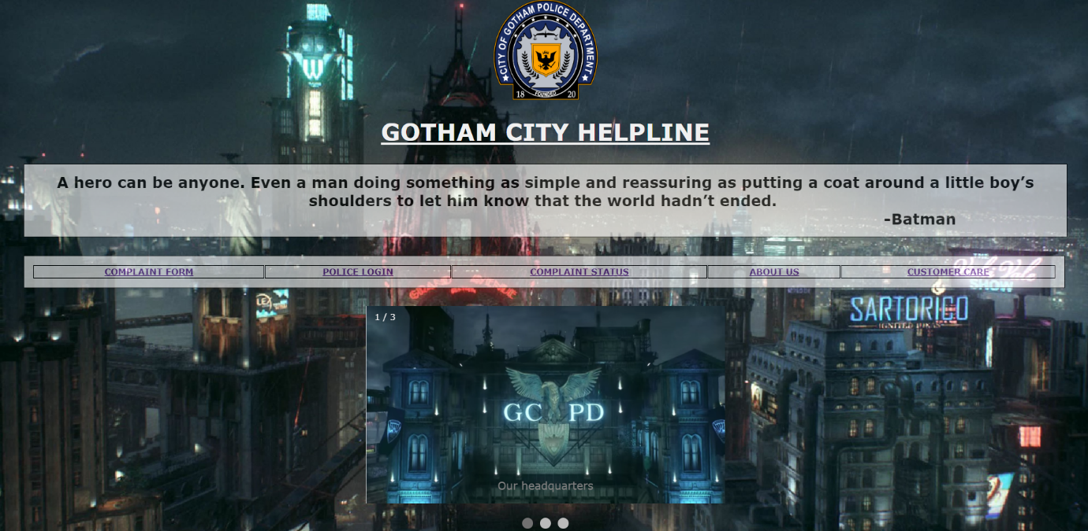

At the bottom, we have a slideshow of our city’s proud task force and organizations which in coordination helps in serving the citizens.

**About page:**

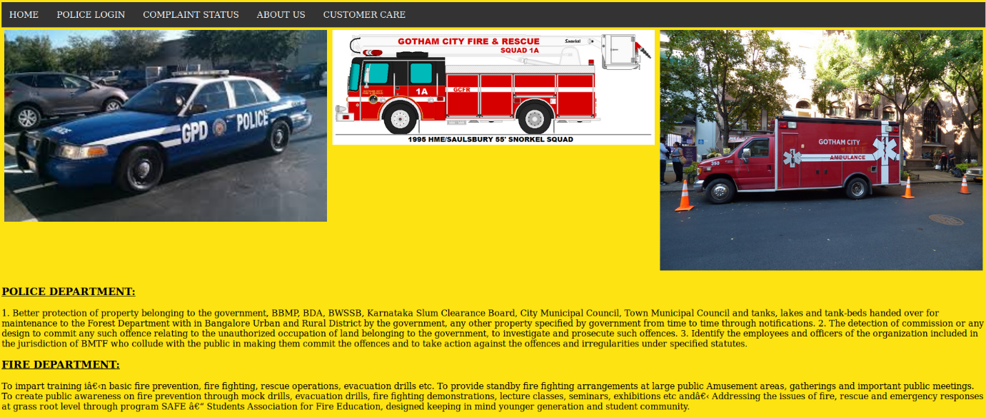This webpages displays the information of the city’s task force which in any emergency, helps the citizens.

The navigation bar stays at all the pages to help navigation easily without going back multiple times.

**Customer care:**

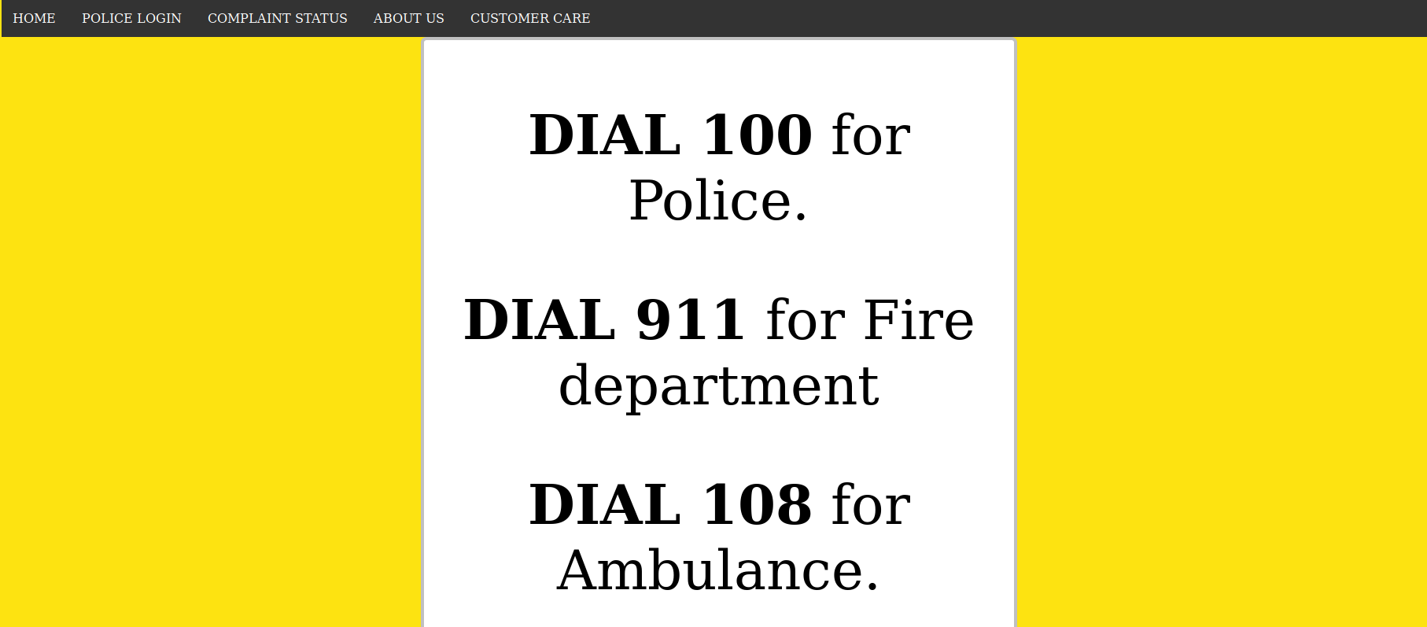

Currently, we don’t handle emergency situations through website. Incase of any emergency, the user can dial the above numbers to get help in an emergency.

**Complaint form:**

If a citizen has faced any mishap, he can register his complain through this website by going to this tab.

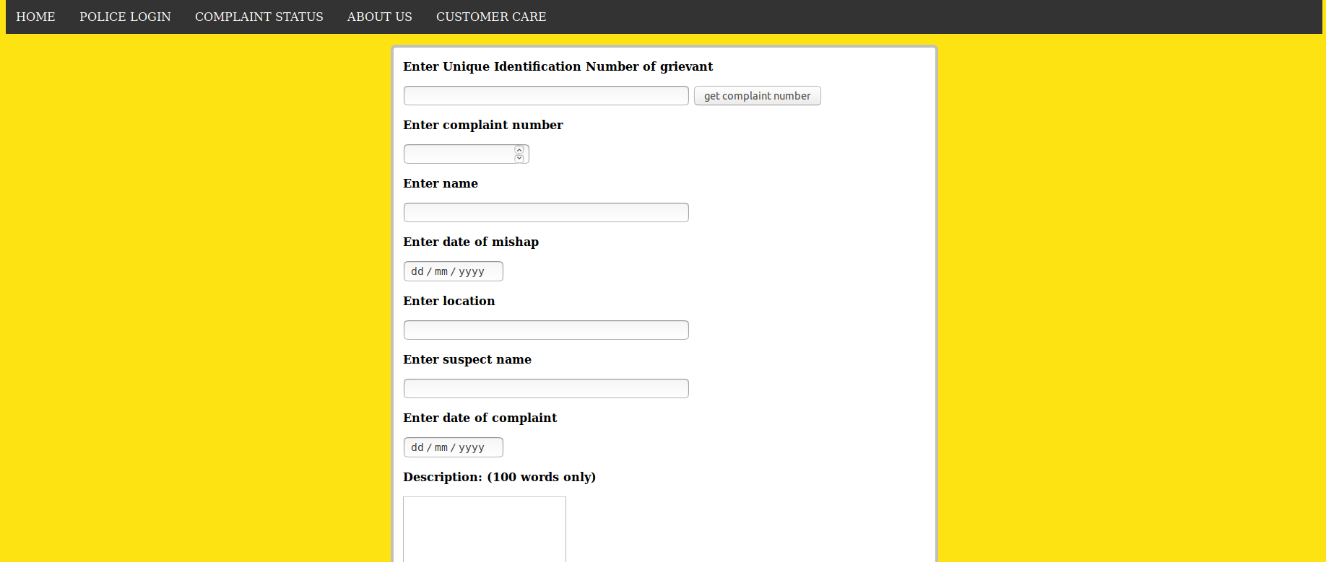

The citizen has to fill out all the details by himself. This information is stored in the database which is used by the police department.

Javascript is used to generate a complaint number through the citizen’s UID.

Example

: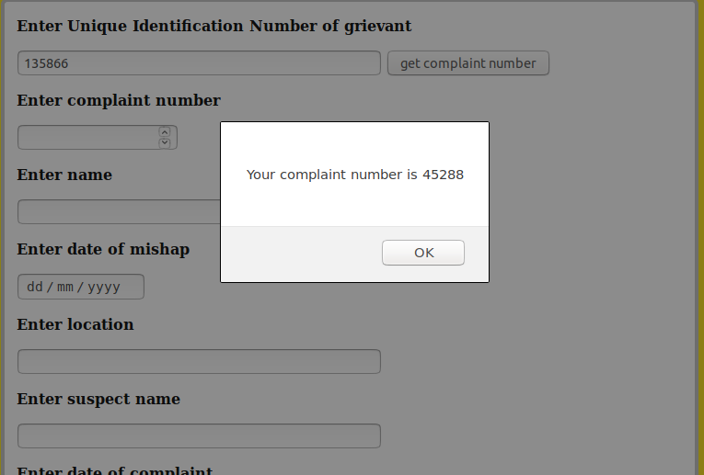

This number is to be entered by the user and this complaint number is to be used by the police.

**Hospital info:**

If a citizen due to an unfortunate citizen has been admitted to a hospital and wants to give it to the police with the complaint the he can do it by clicking the link at the bottom of the complaint form.

This form takes the details of the patient and which hospital he has been admitted to. This information can also be used to give insured amount. 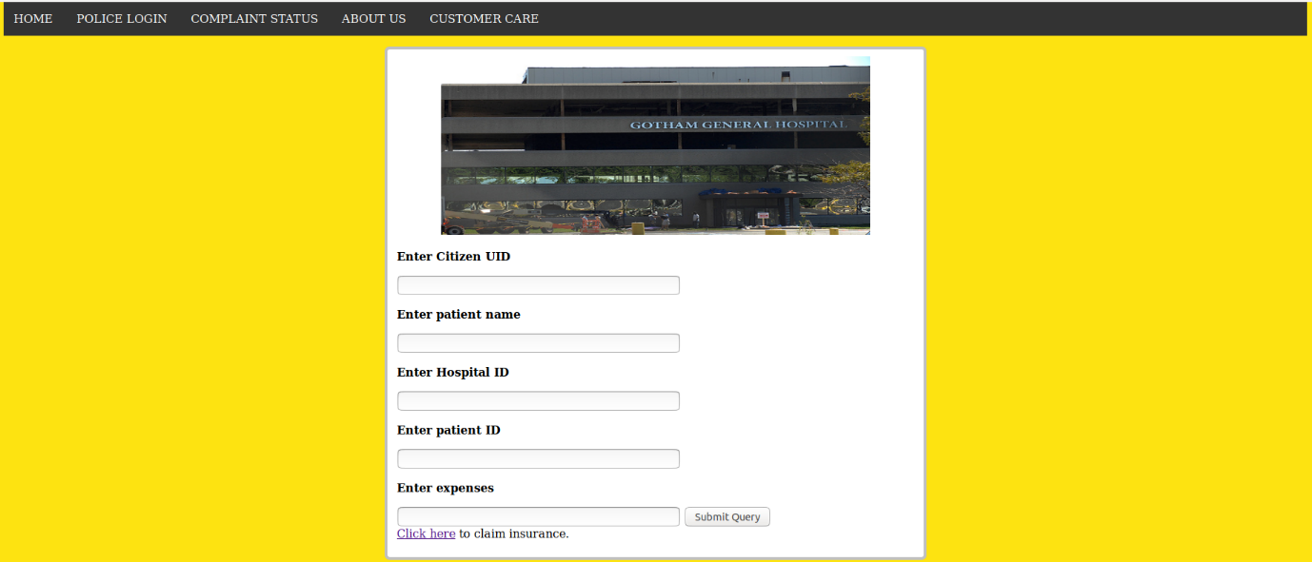

**Insurance information:**

We use this form to record the details of an insurance plan if a citizen has one and to give him the insured amount in-case any mishap occurs.

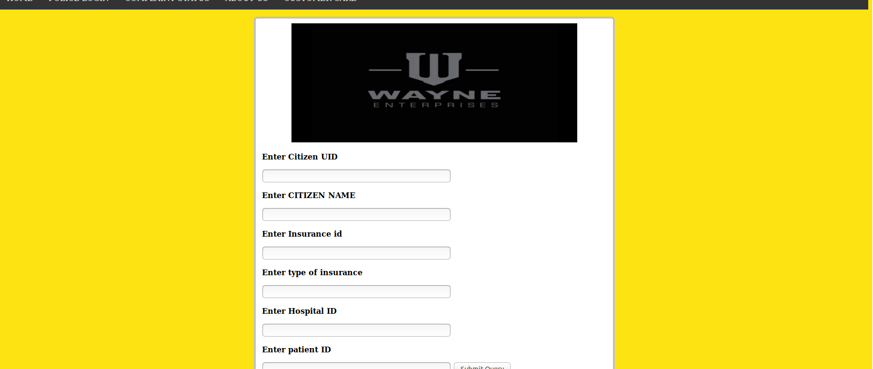

The details that can be entered by the user has to an end.

The police can also use this website to retrieve a citizen’s information, assign inspector to a case, update complaint status.

Since everyone shouldn’t be able to retrieve or change such information, we use a login page.



If someone tried to enter it through the wrong credentials, we directed them to another page.



If correct credentials are entered, we direct them to a police home page where the police can retrieve information, update status of a complaint or assign an inspector in-charge of the case.

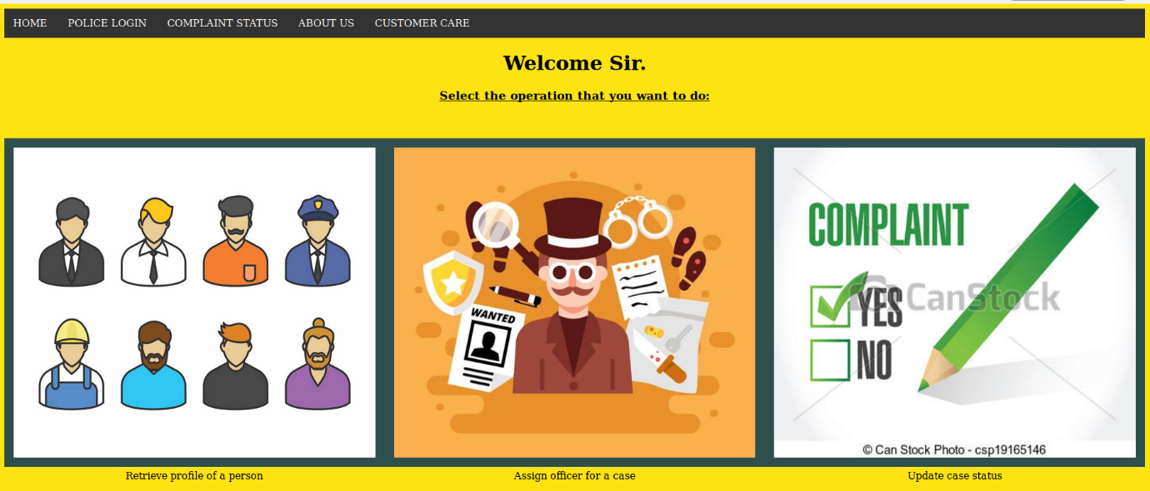

To retrieve profile of a person, we create a form to take in the UID:

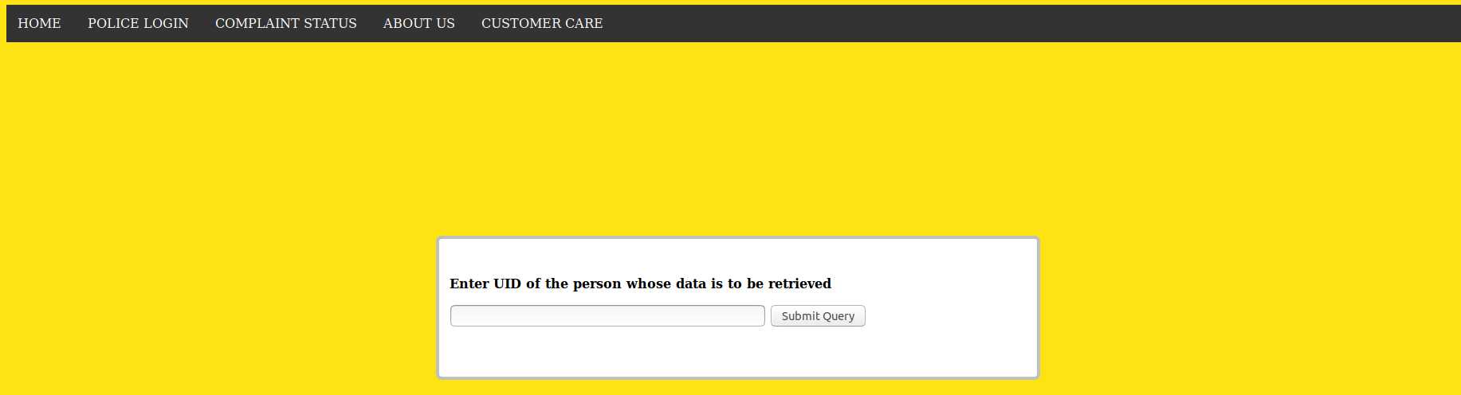

**To assign police:**

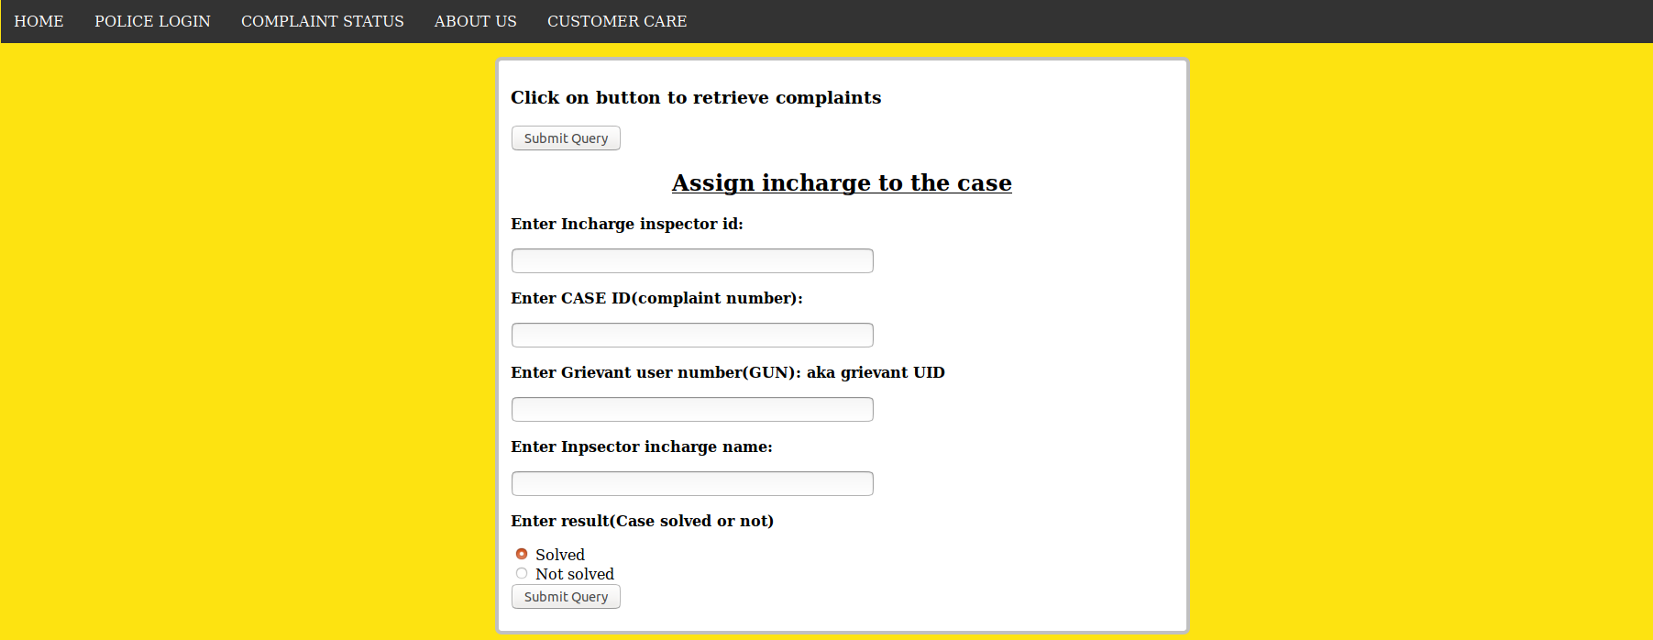

The police must know the different complaints that have been given to assign an inspector. Hence, we use PHP to retrieve all complaint numbers to be assigned an inspector.

We use javascript to let the users know when the data is sent to the server i.e., we open a pop-up window to show that the data has been recorded.

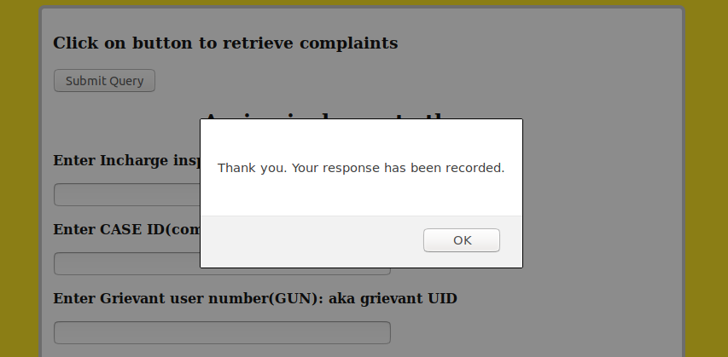

**To update status of a complaint**:

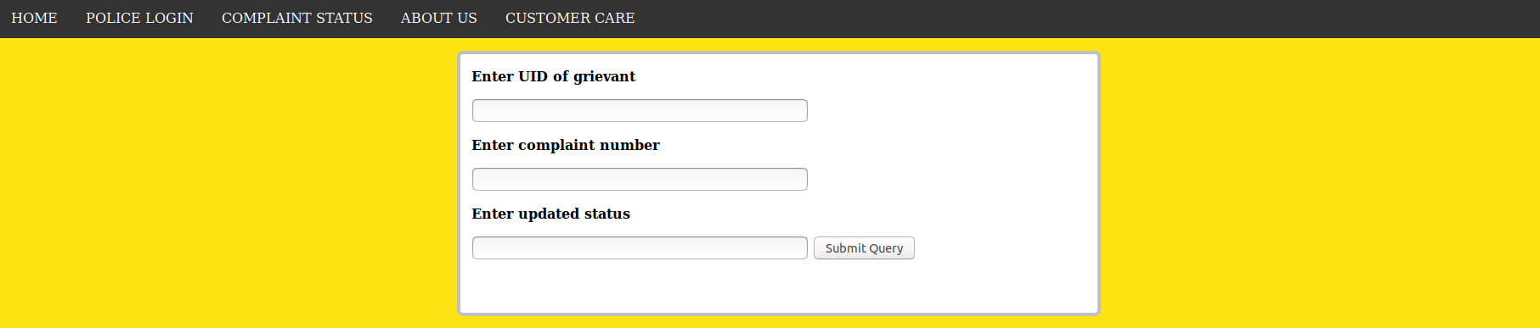

**Checking complaint status:**

A user can also check their complaint status by entering their UID and unique complaint number.

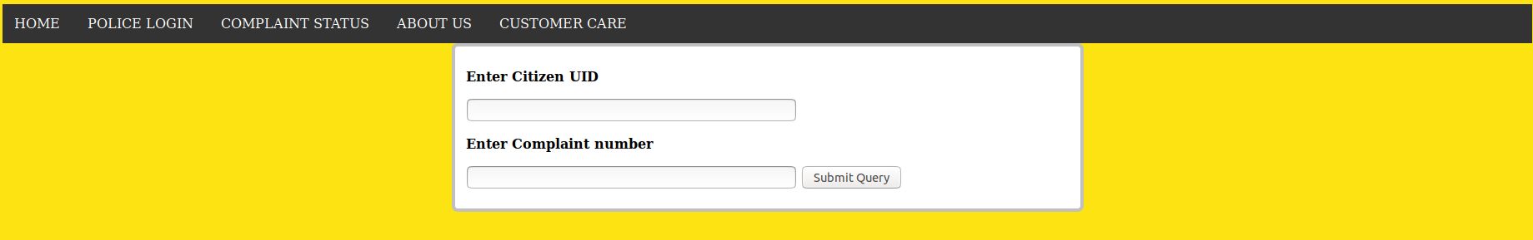

**Server side scripting:**

Server-side scripting is a technique used in web development which involves employing scripts on a web server which produce a response customized for each user's (client's) request to the website. The alternative is for the web server itself to deliver a static web page. Scripts can be written in any of a number of server-side scripting languages that are available (see below). Server-side scripting is distinguished from client-side scripting where embedded scripts, such as JavaScript, are run client-side in a web browser, but both techniques are often used together.

Server-side scripting is often used to provide a customized interface for the user. These scripts may assemble client characteristics for use in customizing the response based on those characteristics, the user's requirements, access rights, etc. Server-side scripting also enables the website owner to hide the source code that generates the interface, whereas with client-side scripting, the user has access to all the code received by the client. A down-side to the use of server-side scripting is that the client needs to make further requests over the network to the server in order to show new information to the user via the web browser. These requests can slow down the experience for the user, place more load on the server, and prevent use of the application when the user is disconnected from the server.

When the server serves data in a commonly used manner, for example according to the HTTP or FTP protocols, users may have their choice of a number of client programs (most modern web browsers can request and receive data using both of those protocols). In the case of more specialized applications, programmers may write their own server, client, and communications protocol, that can only be used with one another.

Programs that run on a user's local computer without ever sending or receiving data over a network are not considered clients, and so the operations of such programs would not be considered client-side operations.

**In our website**, we use PHP to connect the database to the client side webpage.

The data entered in a form is stored in the database through PHP.

Example: we record the data in the database enter in **user complaint form** through the following code:

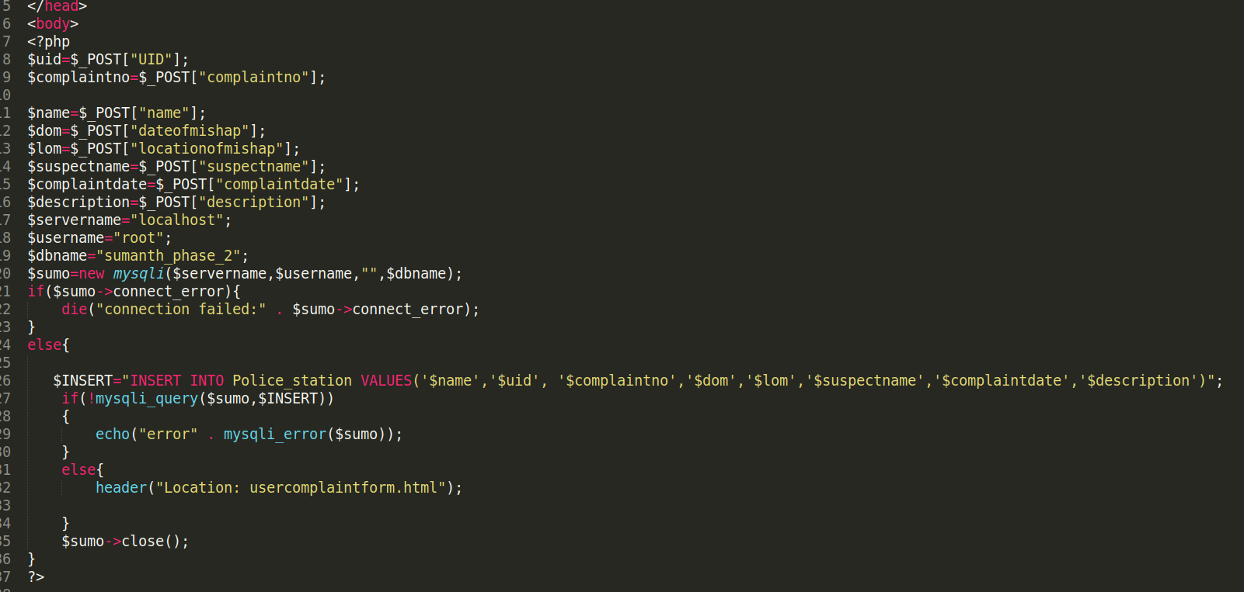

Similarly the hospital info and insurance info are recorded in the database.

For the police to assign inspector we use the following code:

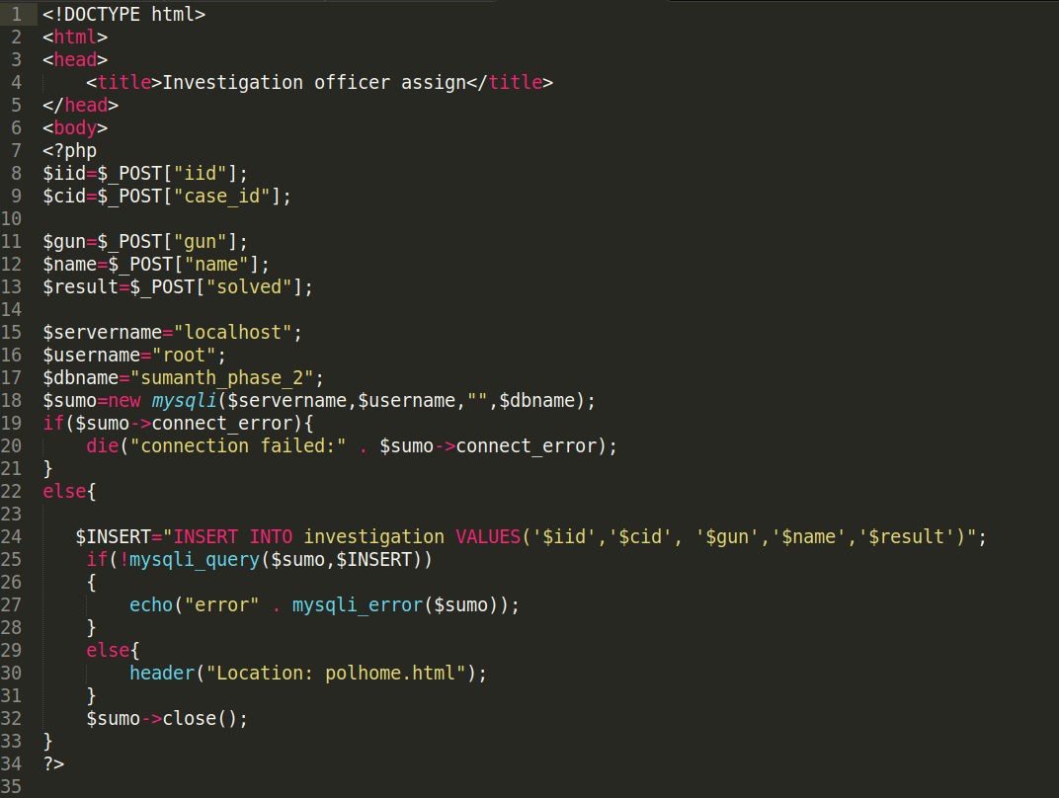

**PHP to validate login:**

The login credentials can be validated through PHP using the following code:

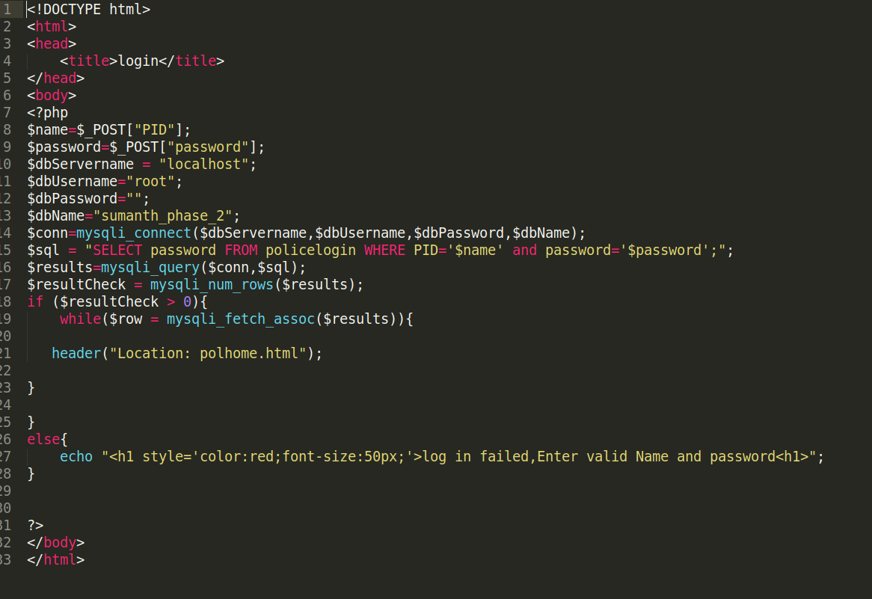

**We can also retrieve the data stored in the database through PHP:**

**Example: to retrieve complaint status of a citizen**

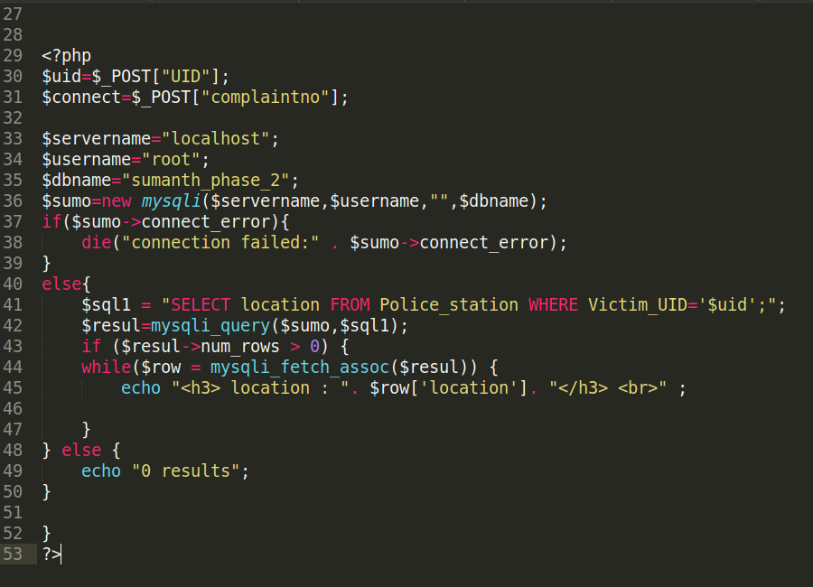

A citizen’s information can be retrieved through the following code.

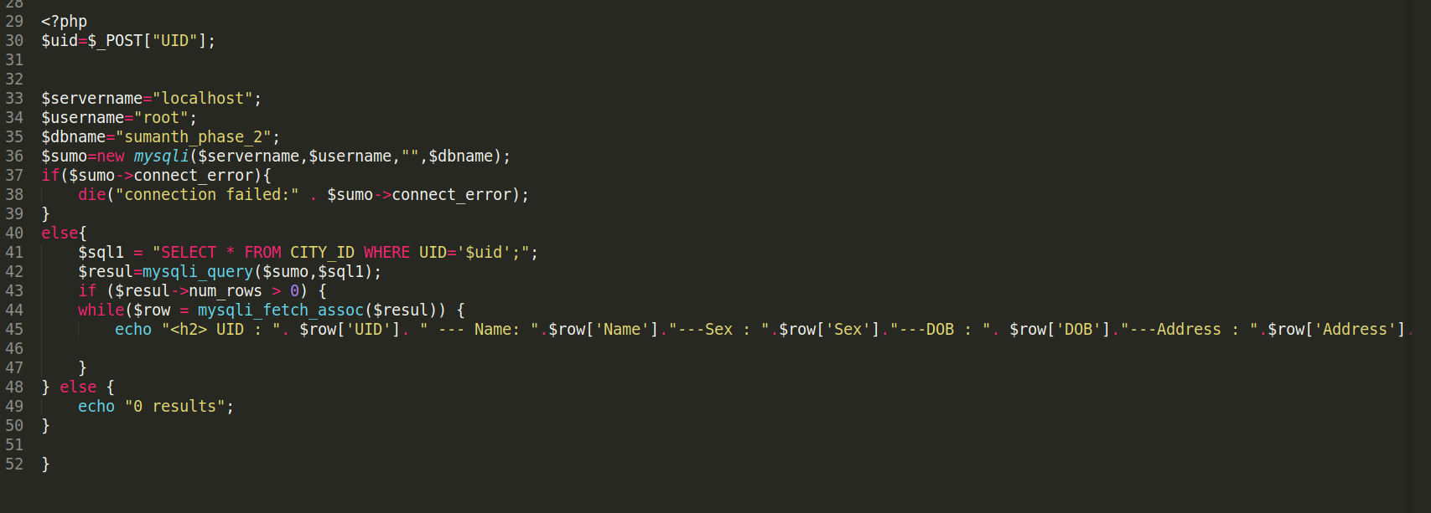

When the police wants to retrieve the complaints to assign police, the get the following output:

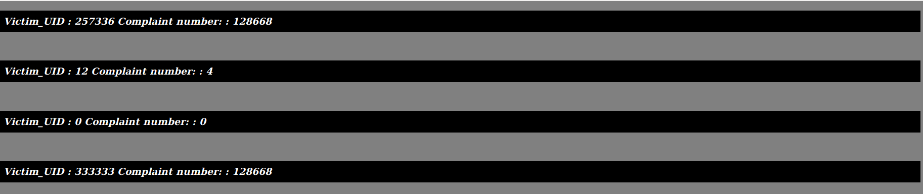

**Therefore, we have now connected the website to the database and we can use the database to store, retrieve, manipulate data in the database.**